STD Verifier Tool Guide

Exporting STD to Excel
Open DOORS → Navigate to your assigned STD module.
1. Navigate to the File menu.
2. Hover over Export.
3. Select Microsoft Office → Excel...
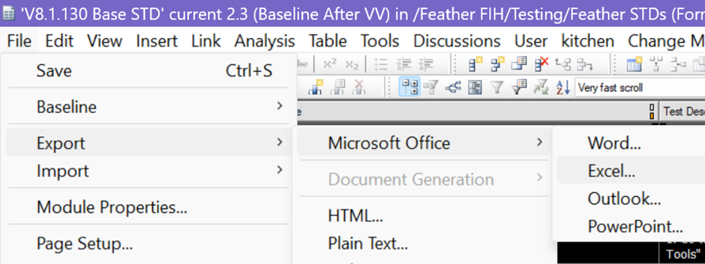

Export Settings
In the export dialog:
- Select Object Heading and Text.
- Check the “Preserve rich text formatting” text box.
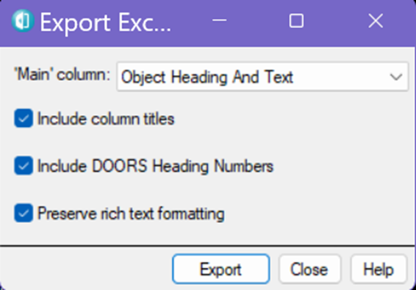

Finalize Exported Excel File
After the STD is exported and opened in Excel:
1. Review the content to ensure formatting and structure are preserved.
2. Click File → Save As to store the file in your designated location.
3. Close the Excel file to complete the export process (EXCEL MUST BE CLOSED).

Accessing the STD Verifier Tool
To launch the STD verification tool:
1. Navigate to the following path: L:\Testing\Tools\TempTest\STD_Verifier_V1
2. Locate the file named AT_baseline_verifier.exe
3. You can either:
- Double-click to open it directly, or
- Right-click → Send to → Desktop (create shortcut) for quick future access.
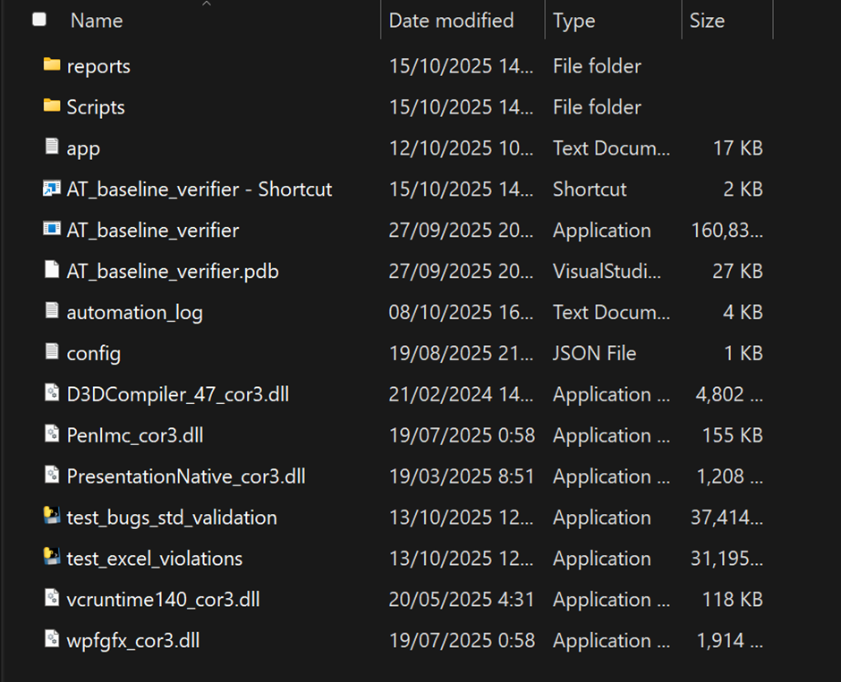

Using the STD Baseline Verifier Tool
The STD Baseline Verifier is designed to validate exported STD Excel files against VSTS bug tracking and internal rule compliance.
Tool Interface Overview:
1. Select STD (Excel) - Button: Click or drag the exported STD Excel file from DOORS.
2. STD Name – Input Field: Enter the name of the STD document.
3. Iteration Path – Input Field: Specify the iteration path used.
4. Current V&V Version – Input Field: Input the current V&V version.
5. Check STD Bugs in VSTS - Button: Validates STD entries against VSTS fields (STD ID, Iteration Path, LastReproducedIn).
6. Validate STD Rules - Button: Checks for rule violations:
Rule 1: Each Test with Expected Results has Test Results.
Rule 2: Tests with no expected results do not have test results.
Rule 3: Each Pass [Test Results] doesn’t have defect number.
Rule 4: Each Fail [Test Results] has a defect number.
7. Last Report - Button: Opens the most recent validation report.
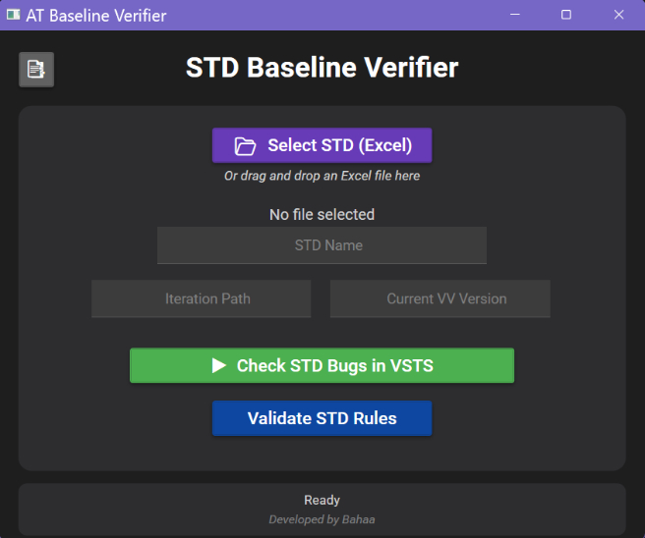

Running STD Validation and Bug Checks
Bug Verification in VSTS:
- Button: Check STD Bugs in VSTS
- Function: Iterates through the STD Excel file and validates STD ID, Iteration Path, and LastReproducedIn fields against VSTS.
STD Rule Validation:
- Button: Validate STD Rules
- Function: Checks for violations based on the following rules:
Rule 1: Each Test with Expected Results has Test Results.
Rule 2: Tests with no expected results do not have test results.
Rule 3: Each Pass [Test Results] doesn’t have defect number.
Rule 4: Each Fail [Test Results] has a defect number.
Accessing the Last Report:
- Button: Last Report
- Function: Opens the most recent validation report for review.

